Interactive Spectral Smoothing

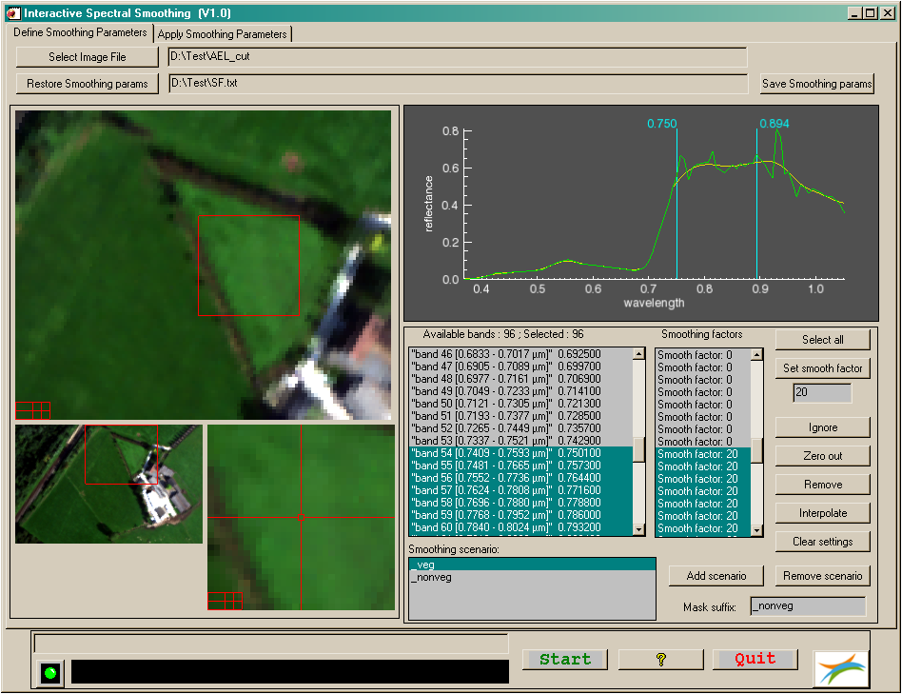

NAME:

**EOSap_Smoothing**

PURPOSE:

This application will perform spectral smoothing of hyperspectral images.

CATEGORY:

Applications - Hyperspectral

ALGORITHM: The ENVI integrated **Interactive Spectral Smoothing** algorithm.

Hyperspectral images often contain noise or error features due to the limited accuracy of calibrations, measurements and models that were used during data collection and processing. Existing smoothing and polishing algorithms not always lead to a satisfactory result.

With the **Interactive Spectral Smoothing** it is possible to subdivide the spectrum in discrete groups of wavelengths for which individual smoothing factors can be defined. By this it is possible to preserve important or delicate parts of the spectrum, while other parts can be treated more roughly.

Nevertheless, extreme care should be taken as not to introduce additional artefacts. Therefore it’s recommended that test runs are made on representative parts of the hyperspectral image and that the results will be verified very accurate before final processing is done.

The smoothing algorithm is based on the weighted mean of spectral values of neighbouring wavelengths. Because it’s possible to subdivide and smooth selected parts of the spectrum, distinction has to be made between starting, middle and ending wavelengths of the selected spectral range. The degree of smoothing is simply accomplished by iterative running the algorithms the number of times specified in the input. The smoothing algorithms can be written as :

Starting wavelength : 

Middle wavelength : 

Ending wavelength : 

DESCRIPTION:

The application has two tab-windows, ‘Define Smoothing Parameters’ in which all smoothing related parameters and options can be specified and ‘Apply Smoothing Parameters’ in which the images to be smoothed can be selected.

* Required input for defining the smoothing parameters:
* Use the [Select Image File] button to browse to the hyperspectral image to be smoothed.
* Once the smoothing parameters are defined they can be saved to a file for later use by using the [Save Smoothing params] button.
* Previously saved smoothing parameters can be restored by the [Restore Smoothing params] button.
* Required input for applying the smoothing parameters:
* Use the [Input directory] button to browse to the directory where the hyperspectral images are located which have to be smoothed.
* Use the [Output directory] button to specify the output directory.
* Use the [Start] button to start the actual smoothing process on the highlighted images in the image list.
* Defining the smoothing parameters:
* Once an image is selected it is displayed in the scroll, image and zoom window. The image and zoom window can be zoomed in and out. The red zoom boxes in the scroll and image window can be moved around by holding the left mouse button while the cursor is within the red canvas.
* As soon as the image is displayed, the spectral profile for the central pixel in the zoom box, indicated by the yellow marker, is displayed in the spectral profile window in a green colour.
* When defining smoothing parameters, the smoothed spectral profile is automatically overlaid in a yellow colour. When moving the zoom boxes around those spectral profiles are updated to the actual pixel location.
* Selecting a range of wavelengths for which a certain smoothing factor has to be assigned can be done in three ways:
  1. Highlight the required wavelengths in the ‘Available bands’ list or highlight the required smoothing factors in the ‘Smoothing factors’ list. Both lists are linked. When a range of wavelengths is selected the vertical blue lines in the spectral profile window will be positioned according to the selected wavelength range. The low and high wavelength limit are displayed left and right of these marker lines.
  2. By holding down the left mouse button when positioned on one of the blue marker lines these can be repositioned to the required wavelength range. At the same time the corresponding entries in the ‘Available bands’ list and ‘Smoothing factors’ list are highlighted.
  3. Use the [Select all] button to select all wavelengths present.
* Once the required range of wavelengths is selected, the smoothing factors can be defined. Several options exist:
  1. Set a certain smooth factor by using the [Set smooth factor] button. Therefore write a certain smoothing value in the textbox below this button. The higher the value the stronger the spectral profile will be smoothed. A zero value will not change the spectral profile for the selected spectral range. The influence of setting these smoothing values can directly be observed via the yellow spectral profile.
  2. A set of wavelengths can be ignored via the [Ignore] button. This means that those selected wavelength bands are not taken into account during the smoothing process. This option is quite similar to setting the smoothing factor to zero, although in that case the bands are indeed taken into account during the smoothing process.
  3. Selected wavelength bands can be zeroed by the [Zero out] button. The selected bands are simply put to a zero in this case.
  4. Bands can be removed by the [Remove button].
  5. A range of selected wavelength bands can be interpolated via the [Interpolate] button. In this case the selected bands are linear interpolated using the spectral values in the band preceding and following the selected spectral range.
  6. Via the [Clear settings] button the defined settings can be cleared for the selected spectral range. This option is identical to setting the smoothing value to zero.
* An option exist to define different smoothing parameters for different selected areas in one image. This is useful as for example spectral profiles for vegetation need to be smoothed in a different way as bare soil has to be smoothed. Therefore different smoothing scenarios can be defined/removed using the [Add scenario] / [Remove scenario] buttons, as an example a vegetation non-vegetation scenario is explained:
  1. Create two masks, one selecting the vegetation the other selecting the non-vegetation pixels. These masks must have the same name as the images to be smoothed and must be located in the same directory.
  2. Each mask must have a unique suffix, e.g. ‘_veg’ and ‘_nonveg’.
  3. Define the smoothing factors for the vegetation pixels, write the suffix name ‘_veg’ in the ‘Mask suffix’ textbox and use the [Add scenario] button the assign the smoothing factors. The same has to be done for the non-vegetation pixels.
  4. When smoothing is applied the two scenarios will be taken into account.

MODIFICATION HISTORY:

- Written by: L.Bertels, April 24, 2009 (V.03)

- Updated by L. Bertels, December 2011 (V.04)

- Interactive visualisation of smoothing parameters.

- Updated by L. Bertels, December 2012 (V1.0)

- First release for the ENVI /IDL Code Library OSI